LESSON 1 WORD FORMAT TEXT - Basics

POINT 1 INTRODUCTION

The aim of this course is to complement your knowledge of text formatting in Word. Particular emphasis will be placed on those aspects that you will need when preparing your thesis.

Learning outcomes

The result of this course4 should be the ability of hassle-free formatting of the raw text to the format of the thesis. We assume that you have already possess the basic knowledge of Word, from high school and middle school education.

Point 2

Headers, footers, Line and Page Breaks, Indent, Styles

Sometimes the text entered into a text editor looks not very nice indeed at the beginning. Reading the text is hard because it has no distinctions. The formatting of your thesis should be perfect. Therefore, we should use various text editor tools, which will allow us to embellish the text.

Exercise 1:

Download the file with the text **article.docx**.

Select the text copy into Word and set it in the style of "No Spacing".

Format the text:

• justified

• font Times New Roman 12 pt

• each new paragraph as follows:

• Use developer view

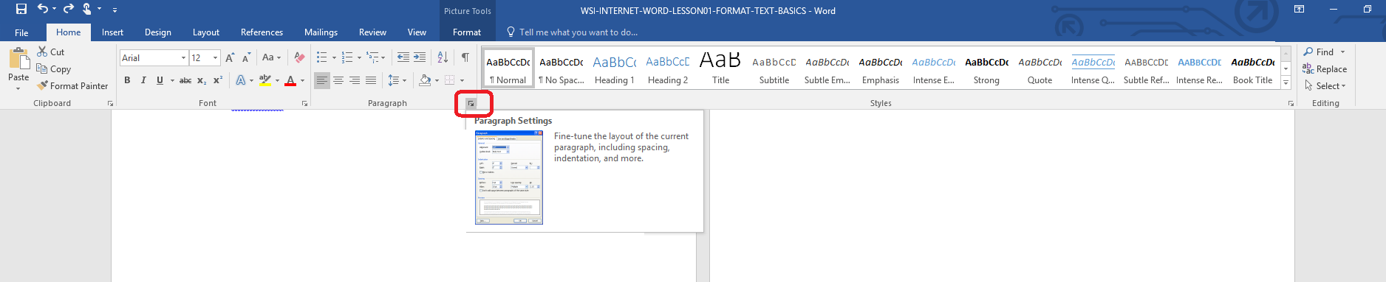

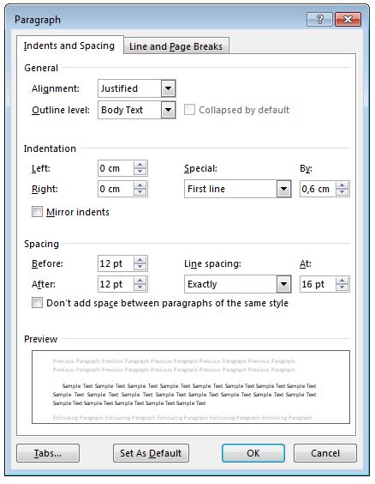

• the first letter as an initial (INSERT → INITIAL”**drop cap**”). The amount of initial lines in set 2.

Around the middle of the page, set the division of pages (INSERTING → page break).

Remember that when you format a paragraph, select Control widow/orphan control (KEY TOOLS → → PARAGRAPH tab: Line and Page Breaks).

**Exercise 2**

In the text, set the header. The header should contain the author's name and the title of the article - the headline should be a marked horizontal line of any length.

Inserting the header

• select from the menu INSERT command header and then edit the header,

• This will move the cursor to the header, in which you can enter: author, title,

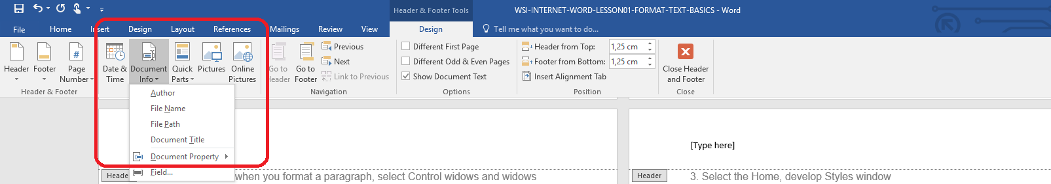

• draw a line in the header: for this purpose activate the INSERT → SHAPES,

• Click on the Close or (Esc) button header and footer located in the Tools menu design;

**Exercise 3**

Inserting page numbers.

• Run command from the menu → INSERT NUMBER PAGE,

• In the opened window, specify the location of page numbers, to be on the bottom right.

The file of these exercises is written to as **article.doc** and thrown into the task folder.

**Exercise 4**

Word Styles let you format your text quickly and easily. You can also change the existing style, create new styles, or delete styles depending on your needs.

Create a new style based on existing formatting:

1. The new document, insert the copied contents of the file before article.doc

2. Format any one paragraph and select it (which is standard).

3. Select the Home, develop Styles window

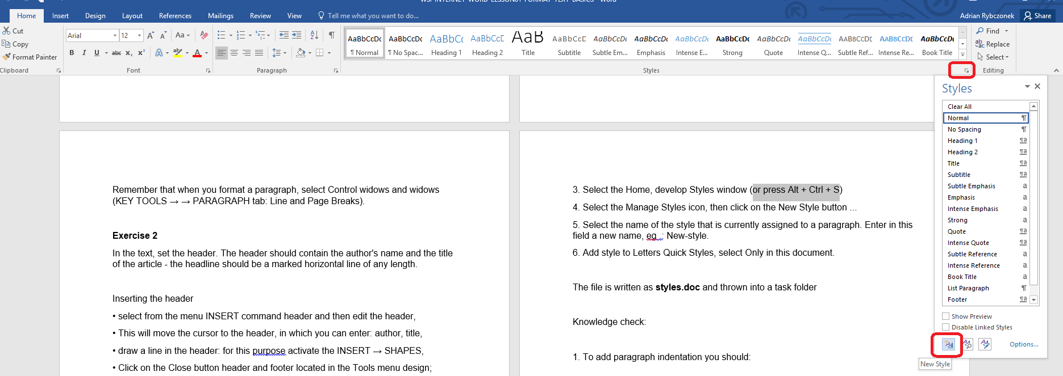

4. Select the Manage Styles icon, then click on the New Style button ...

5. Select the name of the style that is currently assigned to a paragraph. Enter in this field a new name, eg .: New-style.

6. Add style to Letters Quick Styles, select Only in this document.

Knowledge check:

1. To add paragraph indentation you should:

a) click quickly 2 times the left mouse button in the paragraph

b) set the cursor at the beginning of this paragraph and press the Insert key

c) press the Insert key on your keyboard

d) set the cursor at the beginning of this paragraph and press the Tab key

2. Justified mean:

a) align text to the left

b) align text to the left and to the right

c) divide the text into paragraphs.

**Point 3 Summary**

In the attached material we reminded you the most important stages of the formatting associated with the thesis. In the next lesson we present another main activities connected with this subject.